# CITP 155 – Programming I

## IF Statements Lab

## Graded Activity (15 points)

Provide any screen shots using the Snipping Tool and selecting only the relevant portion of the screen (instead of the entire screen). Provide any answers using a blue font. Please note that part of being a good programmer is being precise. If you have typos in your code, such as the words that are supposed to be displayed, you will not receive full credit.

KEEP ALL OF YOUR SOLUTION AND PROJECT FILES THROUGHOUT THE DURATION OF THE CLASS!

Concepts taken from <https://csharp.net-tutorials.com/control-structures/if-statement/>

**Questions (3 points)**

1. What does an IF statement allow?

IF statements allow programmers to set up a logical check, and based on the result of that check, make the computer either execute a block of code or skip that block of code.

1. What are the only two valid results for an IF statement?

True or False.

1. What does the ELSE keyword offer?

It offers a way for programmers to catch all cases not defined by the IF statement.

1. When writing an IF statement, do you always use curly braces? When do you need them?

You don’t have to always use curly braces, as IF statements will assume the next line of code is the code block they should run. You technically only need them for multi-line blocks of code, but I prefer to always use them as it makes the code more readable.

1. What does the || operator mean?

|| is the OR operator, which means if A is true OR B is true, return a Boolean value of true.

1. What does the && operator mean?

&& is the AND operator, which means both A AND B have to be true in order for a Boolean value of true to be returned.

**Create a New Project (2 points)**

Using Visual Studio, open you **Pets** solution.

Create a new Visual C# Console Application project which will be part of the existing **Pets** solution.

Project Name: PetType

Provide a screen shot of the New Project screen before clicking OK.

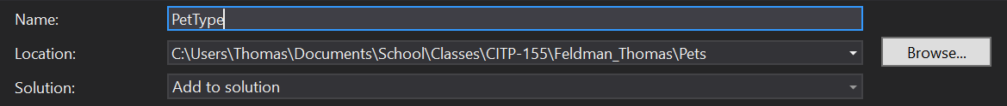

**Open and Modify Your C# Program**

Using the coding examples found at <https://csharp.net-tutorials.com/control-structures/if-statement/> as a guide, create a program that does the following:

* Declare three variables that are string data type. Initially set each variable to **N**.
  + dog
  + cat
  + other
* Using the console, ask the end user this question:  
  **Do you have a dog (Y/N)?**
* Store the response from the end user in the dog variable.
* Using the console, ask the end user this question:  
  **Do you have a cat (Y/N)?**
* Store the response from the end user in the cat variable.
* Using the console, ask the end user this question:  
  **Do you have other types of pets (Y/N)?**
* Store the response from the end user in the other variable.
* If the dog variable equals Y, display the following to the console:  
  **Congratulations on your pet dog!**Please note that you must use **if(dog == “Y”)** for your comparison (2 equals signs)
* If the cat variable equals Y, display the following to the console:  
  **Say hello to your kitty from xxx!**Put your first name in place of xxx
* If the other variable equals Y, display the following to the console:  
  **Your pet must be interesting!**
* Make sure the console pauses at the end so the messages can be read by the end user.
* Test your program. Be sure to test with Y, N, and invalid input on each variable.

Please note: This program does not take the steps to validate the user input, which is an important step for good programming. These concepts will be covered more fully in later lessons.

**Provide Results (10 points)**

Provide a screen shot of your testing when you entered Y for each response. The screen shot should include the title bar of the console with the full path of the program. It should also include nine lines of white text.

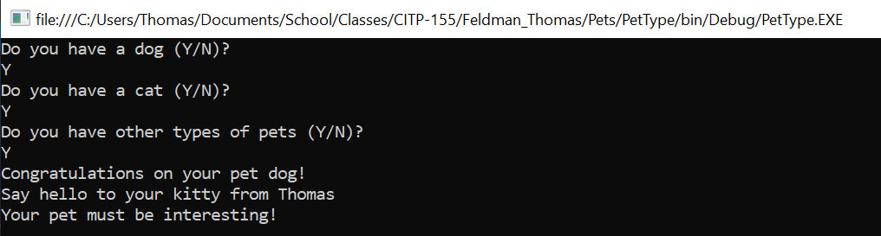

Provide a screen shot of your testing when you entered an N for dog, a Y for cat, and an N for other. The screen shot should include the title bar of the console with the full path of the program. It should also include seven lines of white text.

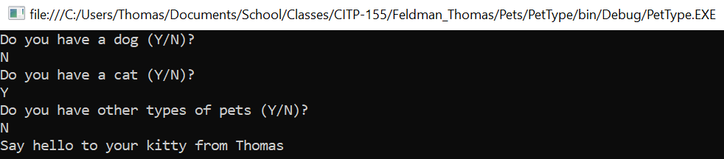

Copy and paste the lines of code from your program here. This is not a screen shot. This is code I can copy and paste to run on my own. This should be 30-40 lines of code, depending on how many blank lines you left in between other lines of code.

using System;

using System.Collections.Generic;

using System.Linq;

using System.Text;

using System.Threading.Tasks;

namespace PetType

{

class Program

{

static void Main(string[] args)

{

string dog = "N";

string cat = "N";

string other = "N";

Console.WriteLine("Do you have a dog (Y/N)?");

if (Console.ReadLine() == "Y") {

dog = "Y";

}

Console.WriteLine("Do you have a cat (Y/N)?");

if (Console.ReadLine() == "Y"){

cat = "Y";

}

Console.WriteLine("Do you have other types of pets (Y/N)?");

if (Console.ReadLine() == "Y"){

other = "Y";

}

if (dog == "Y"){

Console.WriteLine("Congratulations on your pet dog!");

}

if (cat == "Y"){

Console.WriteLine("Say hello to your kitty from Thomas");

}

if (other == "Y"){

Console.WriteLine("Your pet must be interesting!");

}

Console.ReadLine();

}

}

}